Data Visualization in R

Susanti Sarkar

January 24th, 2019

#Class 5  
  
#My first boxplot  
x <- rnorm(1000,0)  
boxplot( x )

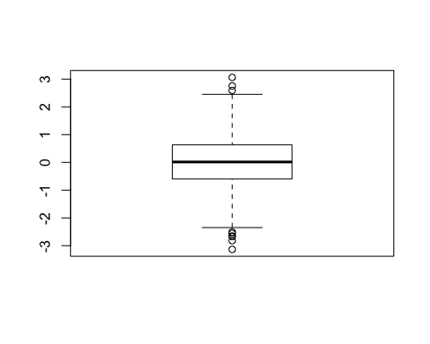

summary(x)

## Min. 1st Qu. Median Mean 3rd Qu. Max.   
## -3.13394 -0.59818 0.01429 0.04012 0.63018 3.06101

hist(x)

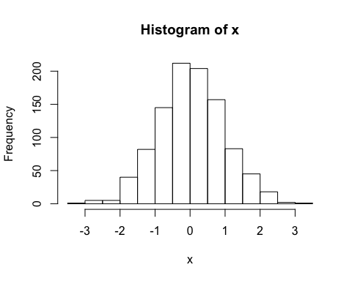

boxplot(x, horizontal = TRUE)

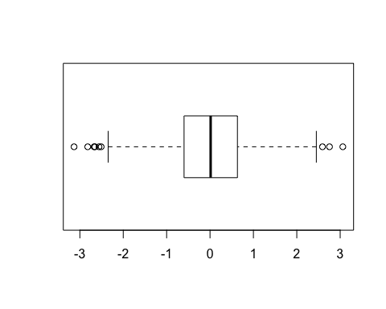

# hands on session  
  
b <- read.table("weight_chart.txt", header = TRUE)  
b

## Age Weight  
## 1 0 3.6  
## 2 1 4.4  
## 3 2 5.2  
## 4 3 6.0  
## 5 4 6.6  
## 6 5 7.2  
## 7 6 7.8  
## 8 7 8.4  
## 9 8 8.8  
## 10 9 9.2

plot(b, type="o", pch=15, cex=1.5, lwd=2, ylim=c(2, 10), xlab = "Age (months)", ylab = "Weight (kg)", main = "Baby Weight with Age")

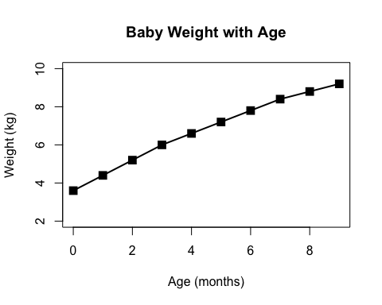

mouse <- read.table("feature_counts.txt", header = TRUE, sep = "\t")  
barplot (mouse$Count, ylab = "Number of features", horiz = TRUE, names.arg = mouse$Feature, las=1)

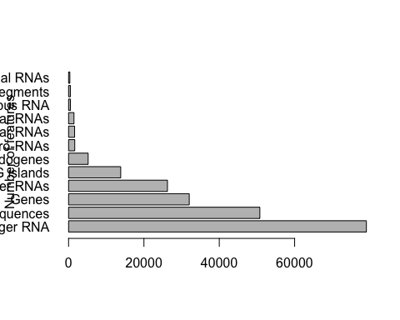

# Change margin so we can see the labels   
  
#add some color  
barplot (mouse$Count, ylab = "Number of features", horiz = TRUE, names.arg = mouse$Feature, las=1, col = rainbow(7))

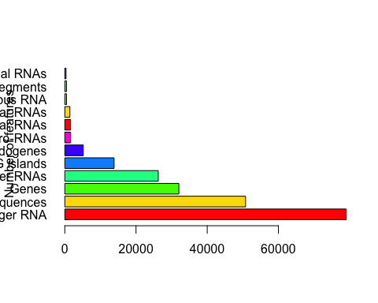

# Section 3A  
gender <- read.table("male_female_counts.txt", header = TRUE, sep = "\t")  
barplot(gender$Count, names.arg = gender$Sample, las=2, col=rainbow(nrow(gender)), ylab = "Counts")

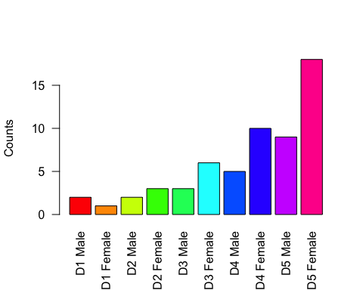

barplot(gender$Count, names.arg = gender$Sample, las=2, col=c("blue", "red"), ylab = "Counts")

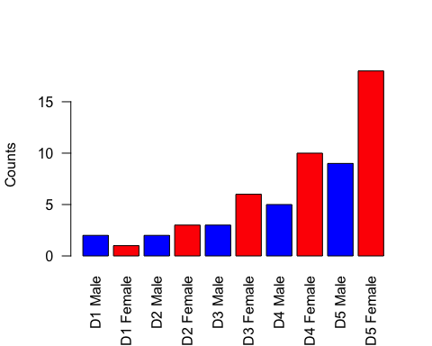

# Section 3B  
gene <- read.table("bimm143_05_rstats/up_down_expression.txt", header = TRUE)